

**CS 255 System Analysis & Design**

**Project II**

# System Design Document

**Southern New Hampshire University**

**Charlotte Mancini**

**October 15, 2022**

## DriverPass UML Diagrams

### UML Use Case Diagram

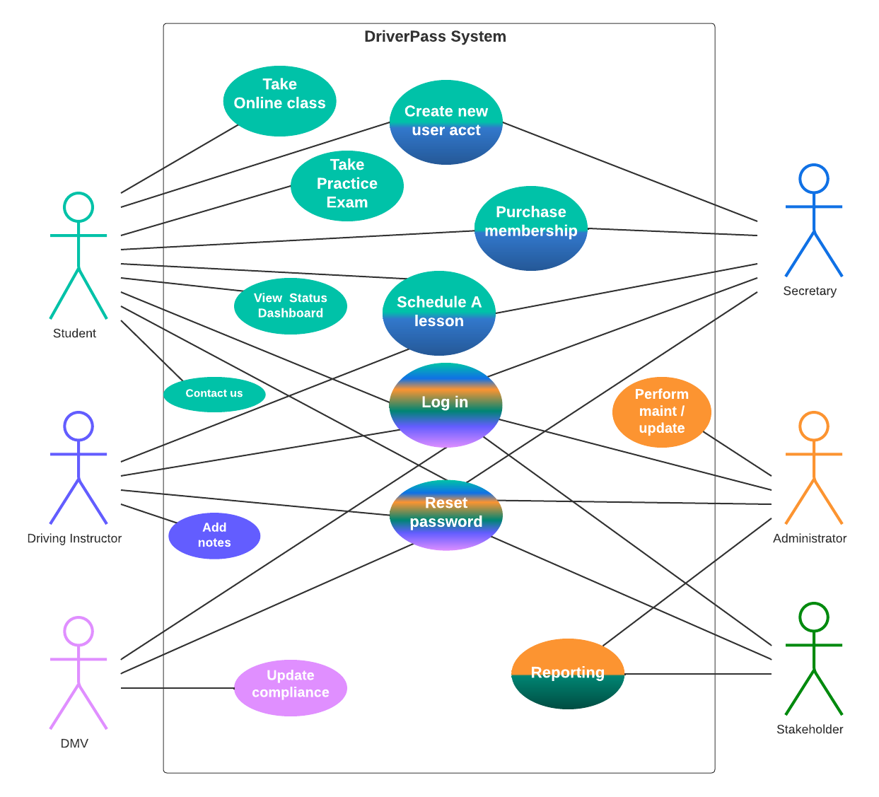

### UML Activity Diagrams

**Purchase a Membership Activity Diagram**

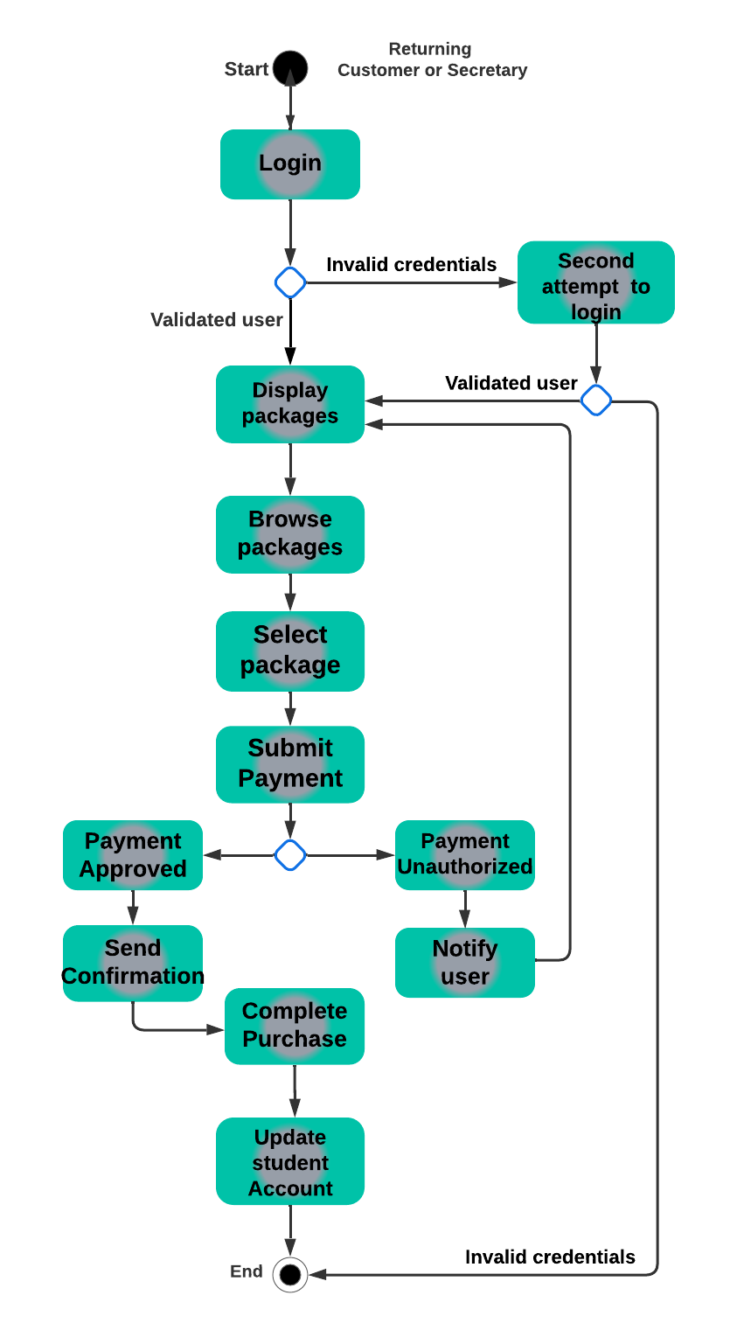

### UML Activity Diagrams

**Schedule a Lesson Activity Diagram**

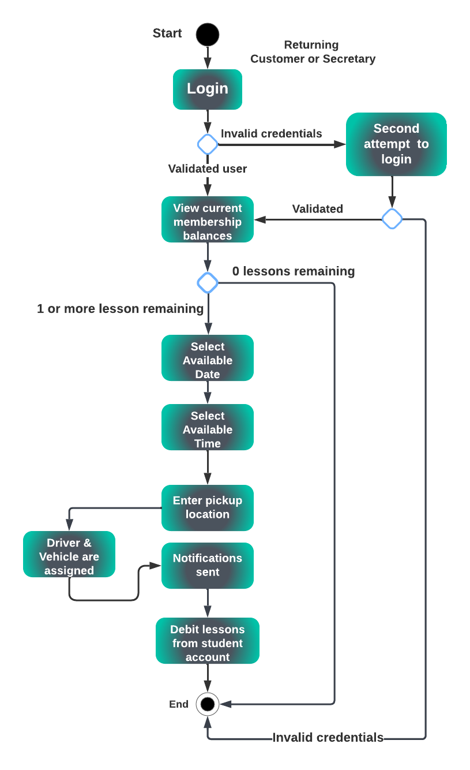

### UML Sequence Diagram

**Purchase Membership Package Sequence Diagram**

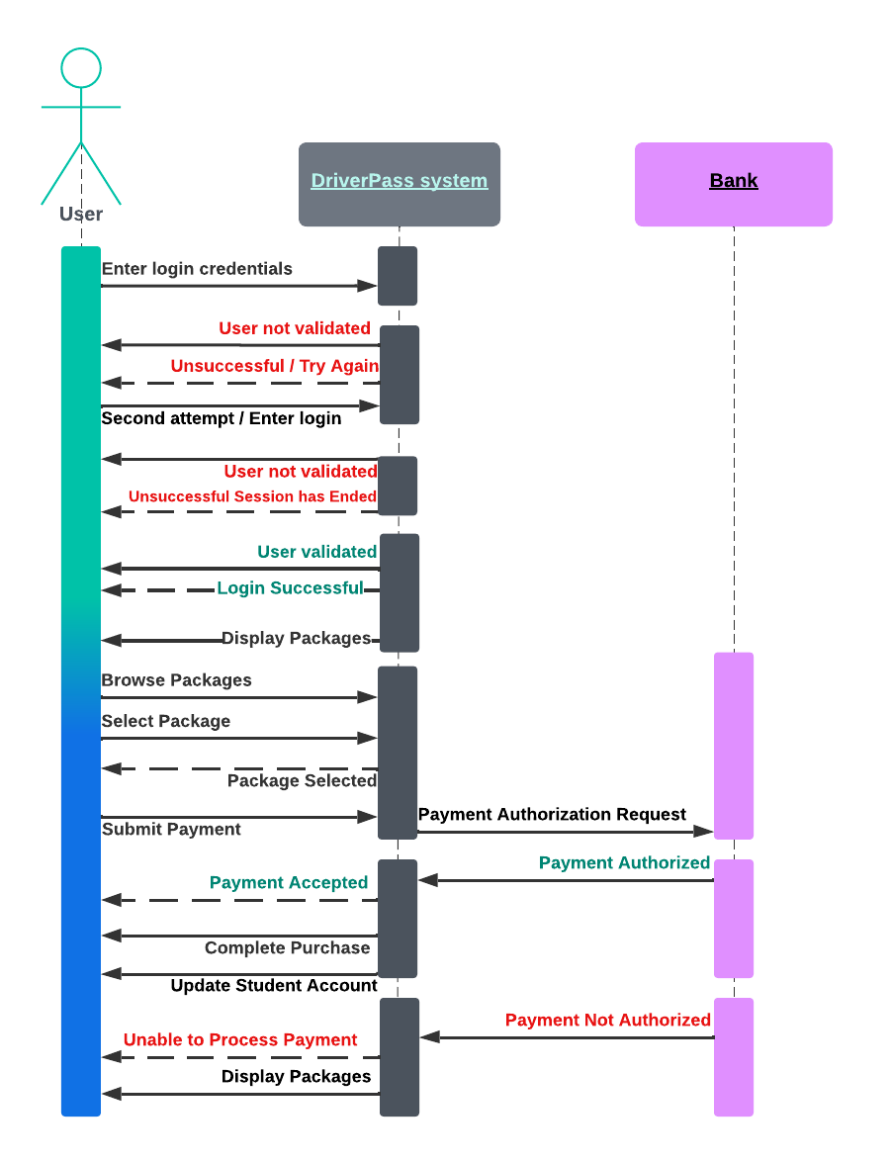

### UML Class Diagram

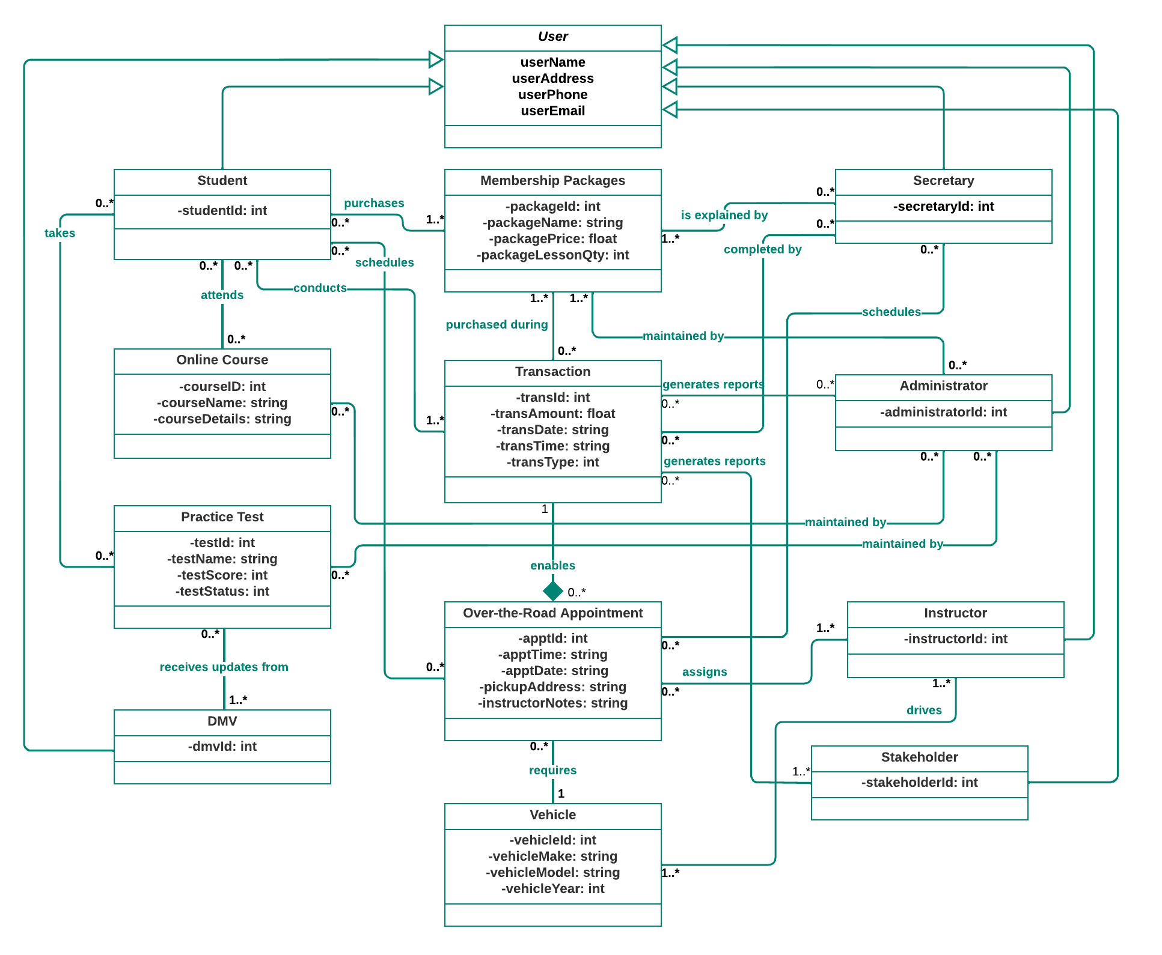

## Technical Requirements

Based on the functional and nonfunctional requirements of the DriverPass system, certain technical requirements have been identified. This system will require a web-hosted server in the cloud, a database server, firewall protection, and sufficient bandwidth to operate properly. Scalable storage capacity, security and backup services are also integral technical components of this system. DriverPass will utilize a Linux operating system and it will be developed with the Java object-oriented programming language. For payment processing, an independent third-party service, either from a bank or other online payment processor such as PayPal, must be integrated prior to launching the application.